

Name : Jaswanth babu R R
Reg No :192512341
Course name : Advanced Wireless Communincation system
Course code : ECA5610

Experiment: 7

MATLAB – Analysis of 5G NR Frame Structure and Subcarrier Spacing

Aim:

To analyze the 5G NR frame structure by studying subcarrier spacing, slot duration, OFDM symbols and simplified downlink/uplink resource assignments using MATLAB, and to relate the radio resources to gNodeB functions and RRC operation.

Objectives

Objectives 1:

- To generate or inspect a simplified 5G NR resource grid.
- To compare selected subcarrier spacings and their effect on symbol or slot duration.
- To identify basic downlink and uplink resource assignments in the model.
To relate the radio resources to gNodeB functions, RAN organization and RRC’s role
SOFTWARE USED:
  - Computer with MATLAB

Program :

clc; clear; close all;
Nsc = 24; % Simplified number of subcarriers
Nsym = 14; % OFDM symbols per slot
grid = zeros(Nsym,Nsc);
% Simplified DL assignment: symbols 1-10
grid(1:10,:) = 1;
% Simplified UL assignment: symbols 11-14
grid(11:14,:) = 2;
figure
imagesc(grid)
grid on
xlabel('Subcarrier Index')
ylabel('OFDM Symbol Index')
title('Simplified 5G NR Time-Frequency Resource Grid')
colorbar

Output:

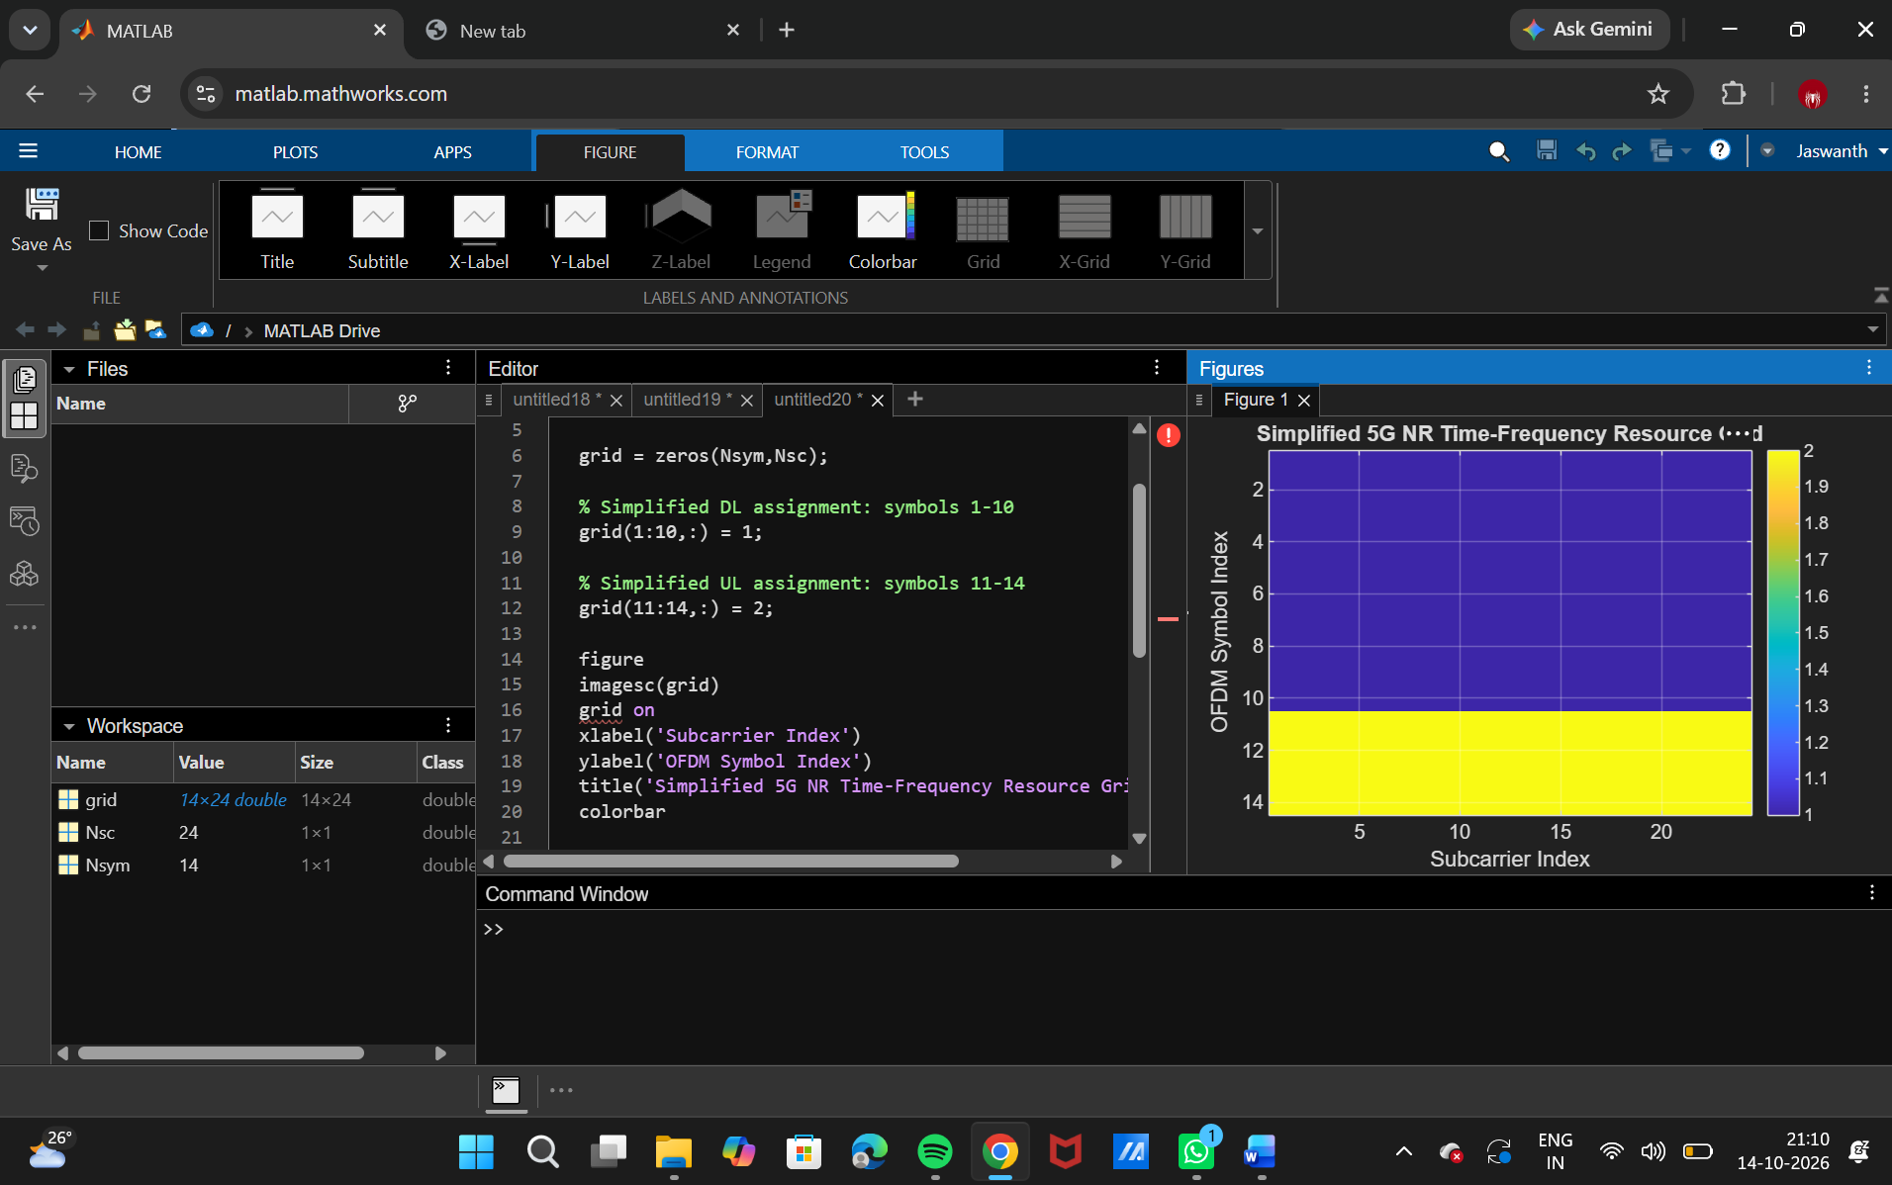

+

OBJECTIVE 2: Compare SCS and Slot Duration

Program :

clc; clear; close all;

scs = [15 30 60 120 240]; % kHz

mu = 0:4;

slot = [1 0.5 0.25 0.125 0.0625]; % ms

figure

plot(scs,slot,'o-','LineWidth',2)

grid on

xlabel('Subcarrier Spacing (kHz)')

ylabel('Slot Duration (ms)')

title('5G NR Slot Duration for Different Subcarrier Spacing')

figure

bar(scs)

grid on

set(gca,'XTickLabel',mu)

xlabel('Numerology Index (\mu)')

ylabel('Subcarrier Spacing (kHz)')

title('5G NR Subcarrier Spacing for Different Numerologies')

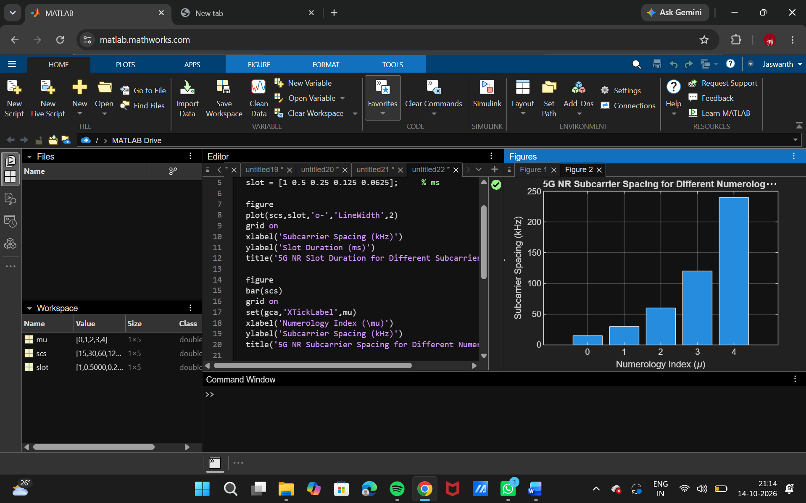

OBJECTIVE 3: Identify Basic DL and UL Resource Assignments

Program :

clc; clear; close all;
symbols = 1:14;
DL = [1 1 1 1 1 1 1 1 1 1 0 0 0 0];
UL = [0 0 0 0 0 0 0 0 0 0 1 1 1 1];
figure
plot(symbols,DL,'o-','LineWidth',2); hold on
plot(symbols,UL,'s-','LineWidth',2)
grid on
xlabel('OFDM Symbol Index')
ylabel('Allocation Status')
title('Simplified Downlink and Uplink Assignment')
legend('Downlink','Uplink')

OUTPUT:

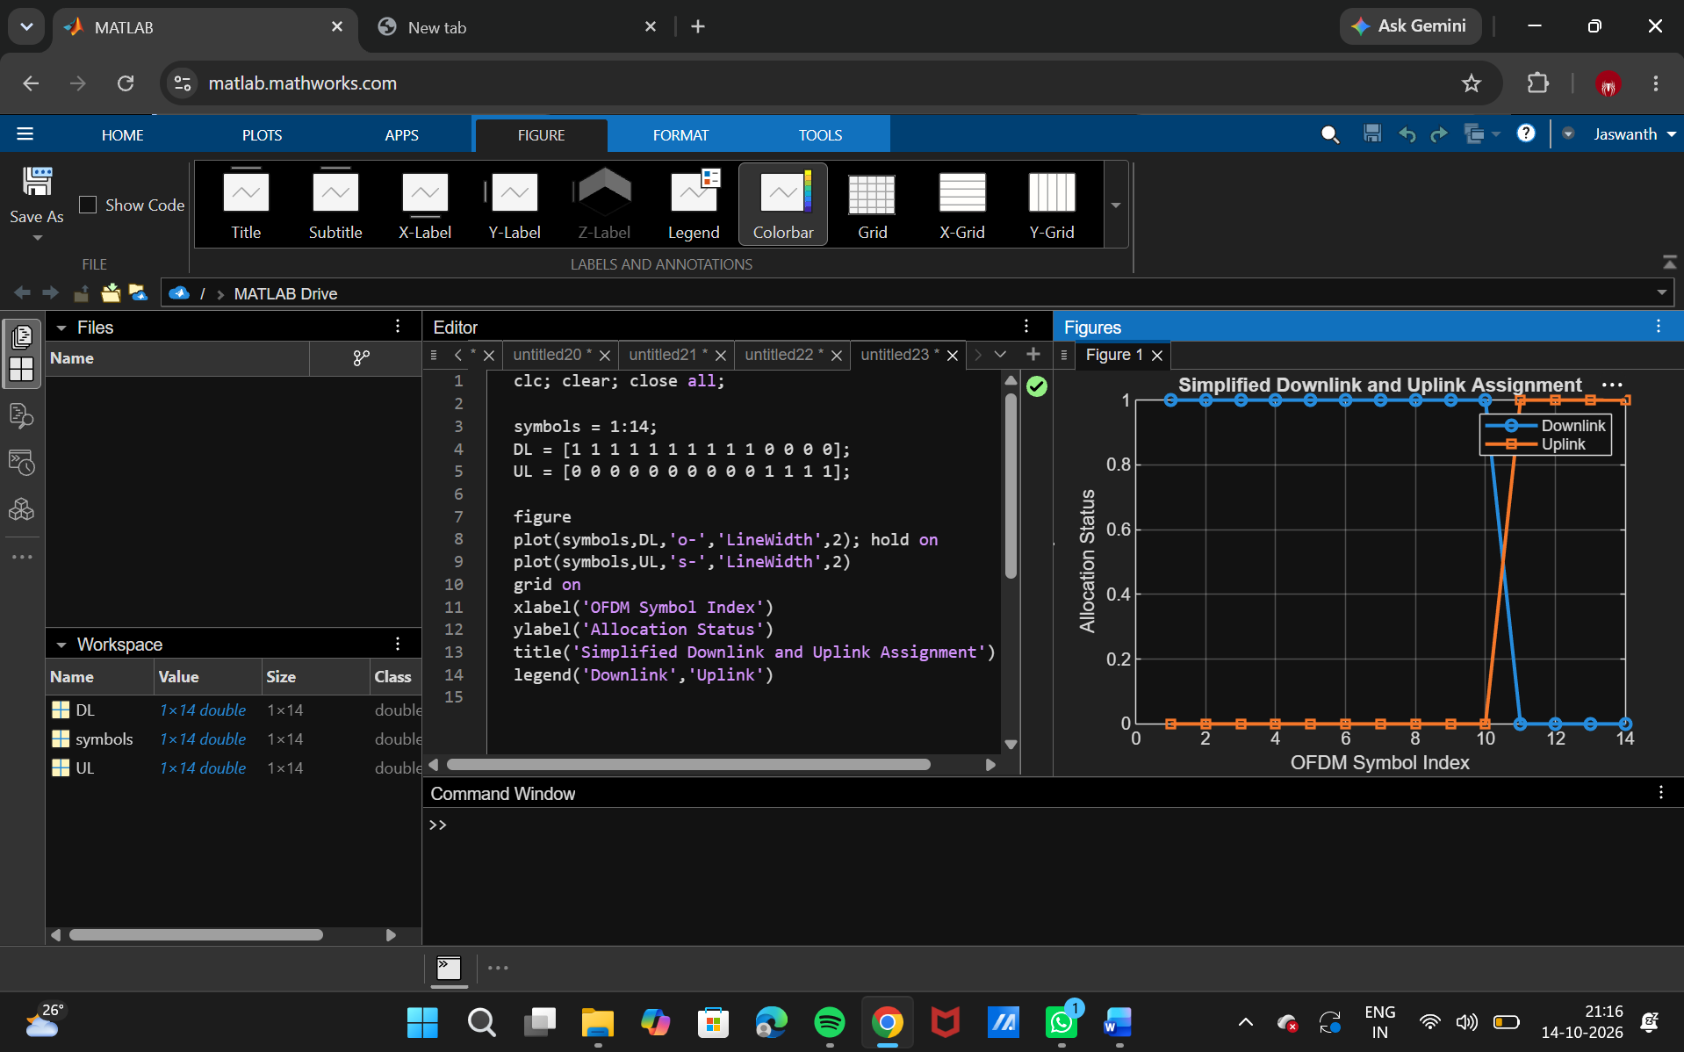

Objective – 4: Relate Resources to gNodeB, RAN and RRC

The gNodeB is the principal 5G NR radio access node. It participates in radio-resource management and scheduling and provides the radio interface between the UE and the 5G core. RRC is a control-plane protocol responsible for radio-resource configuration and connection-related control. The simplified grid therefore represents the radio resources that are scheduled and configured within the RAN; the exact allocation in a live network depends on traffic, channel conditions, QoS and scheduling decisions.

Result

- A simplified 5G NR resource grid was generated and inspected.
- The effect of different SCS values on slot duration was analyzed.
- Basic downlink and uplink resource assignments were represented.
- The relationship among NR radio resources, gNodeB operation, RAN organization and RRC was explained.

